ASSIGNMENT NO.8: Views and Data Abstraction

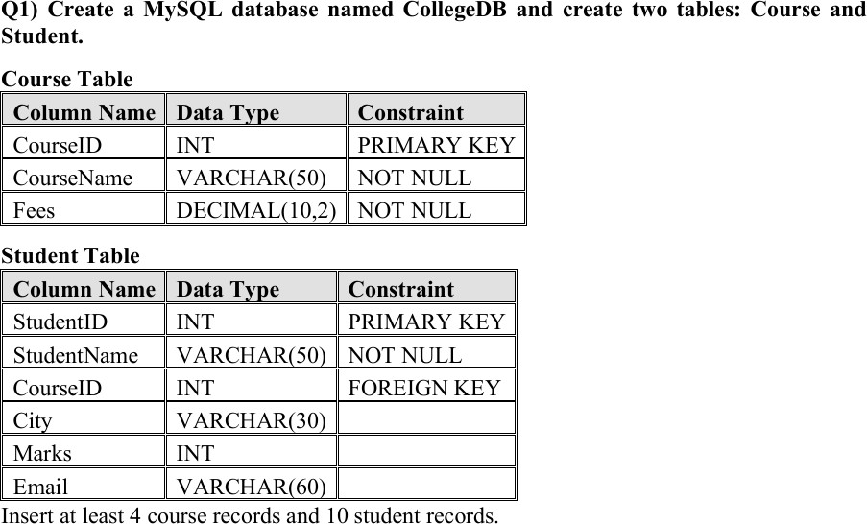

USE CollegeDB;
-- ============================================
-- Q1) CREATE TABLES
-- ============================================

CREATE TABLE Course_View ( CourseID INT PRIMARY KEY,
CourseName VARCHAR(50) NOT NULL, Fees DECIMAL(10,2) NOT NULL
);

CREATE TABLE Student_View ( StudentID INT PRIMARY KEY,
StudentName VARCHAR(50) NOT NULL,

CourseID INT,
City VARCHAR(30),
Marks INT,
Email VARCHAR(60),
FOREIGN KEY (CourseID) REFERENCES Course_View(CourseID)
);

-- Insert 4 Course records INSERT INTO Course_View (CourseID, CourseName, Fees) VALUES
(101, 'BSc IT', 45000.00),
(102, 'BCA', 40000.00),
(103, 'BSc CS', 42000.00),
(104, 'Data Science', 55000.00);

-- Insert 10 Student records INSERT INTO Student_View
(StudentID, StudentName, CourseID, City, Marks, Email) VALUES
(1, 'Rahul Sharma', 101, 'Mumbai', 78, 'rahul@gmail.com'),
(2, 'Priya Patil', 102, 'Pune', 85, 'priya@gmail.com'),
(3, 'Aman Verma', 103, 'Nashik', 67, 'aman@gmail.com'),
(4, 'Sneha Joshi', 101, 'Mumbai', 91, 'sneha@gmail.com'),
(5, 'Karan Mehta', 102, 'Thane', 74, 'karan@gmail.com'),
(6, 'Neha Shah', 101, 'Pune', 88, 'neha@gmail.com'),
(7, 'Rohan Desai', 103, 'Mumbai', 69, 'rohan@gmail.com'),

(8, 'Meera Kulkarni', 102, 'Nashik', 82, 'meera@gmail.com'),
(9, 'Arjun Nair', 101, 'Thane', 59, 'arjun@gmail.com'),
(10, 'Divya More', 102, 'Mumbai', 93, 'divya@gmail.com');

SELECT * FROM Course_View; SELECT * FROM Student_View;

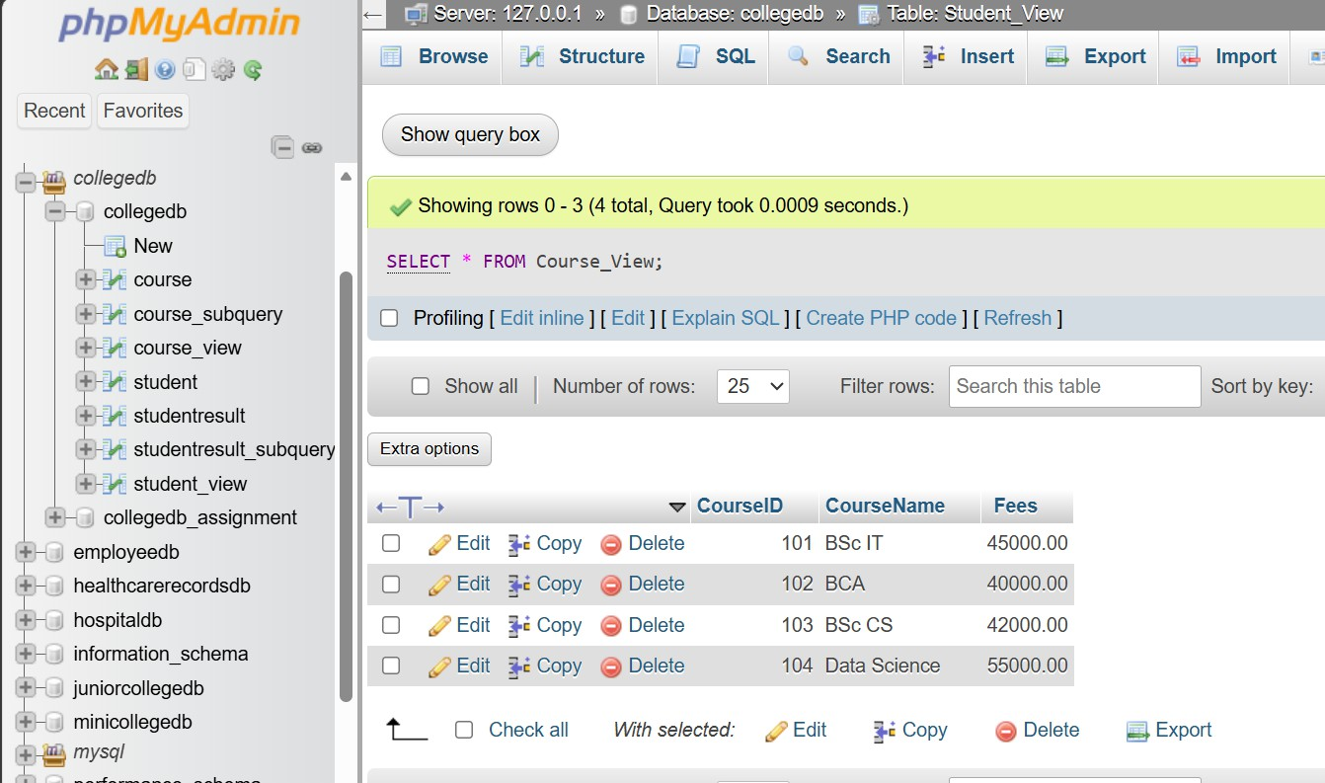
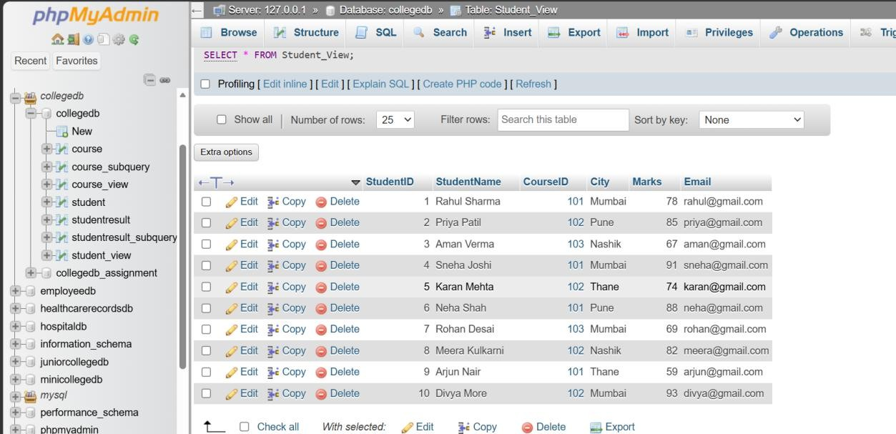

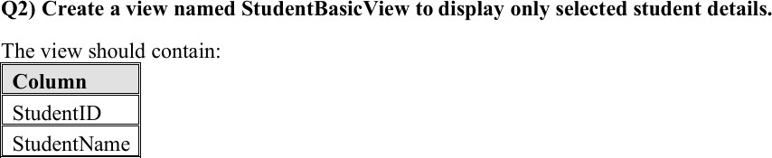
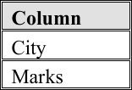

CREATE VIEW StudentBasicView AS
SELECT StudentID, StudentName, City, Marks FROM Student_View;

-- Display the view

SELECT * FROM StudentBasicView;

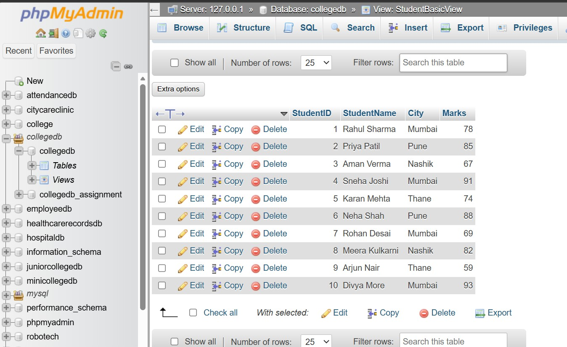

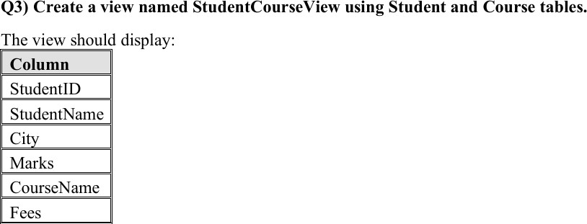

CREATE VIEW StudentCourseView AS SELECT
Student_View.StudentID, Student_View.StudentName, Student_View.City, Student_View.Marks, Course_View.CourseName, Course_View.Fees

FROM Student_View INNER JOIN Course_View
ON Student_View.CourseID = Course_View.CourseID;

-- Display the view
SELECT * FROM StudentCourseView;

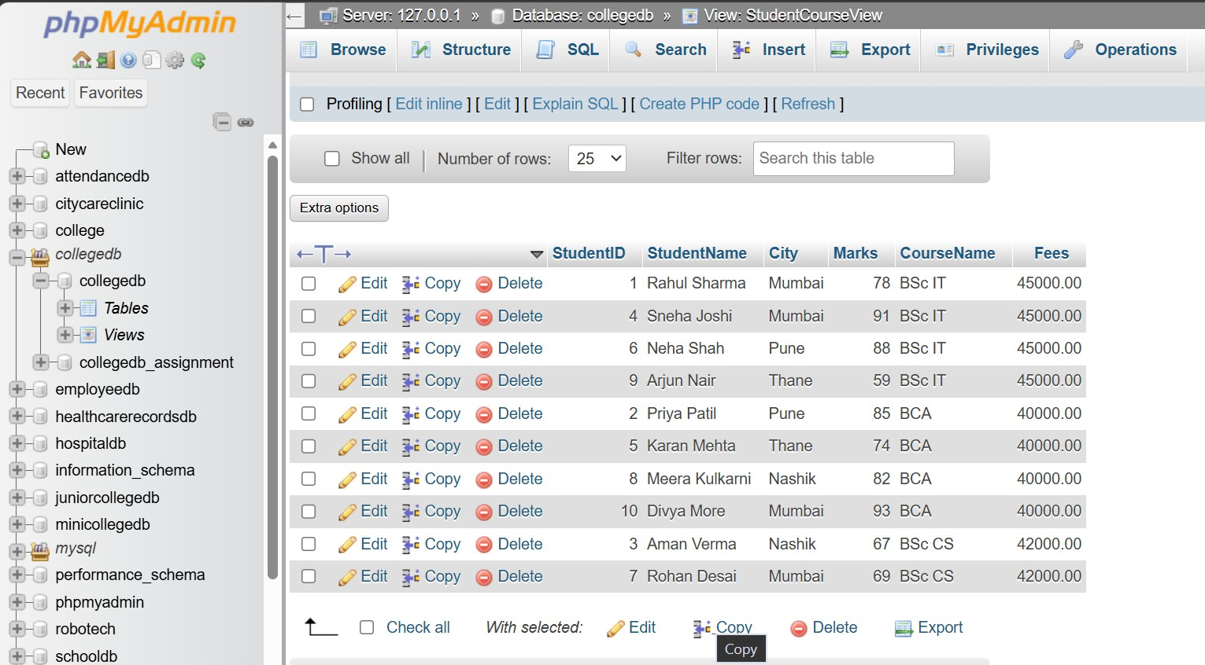

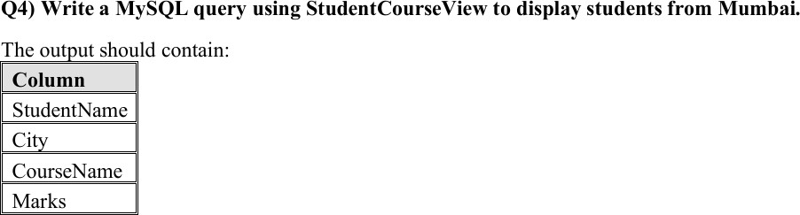

SELECT StudentName, City, CourseName, Marks FROM StudentCourseView
WHERE City = 'Mumbai';

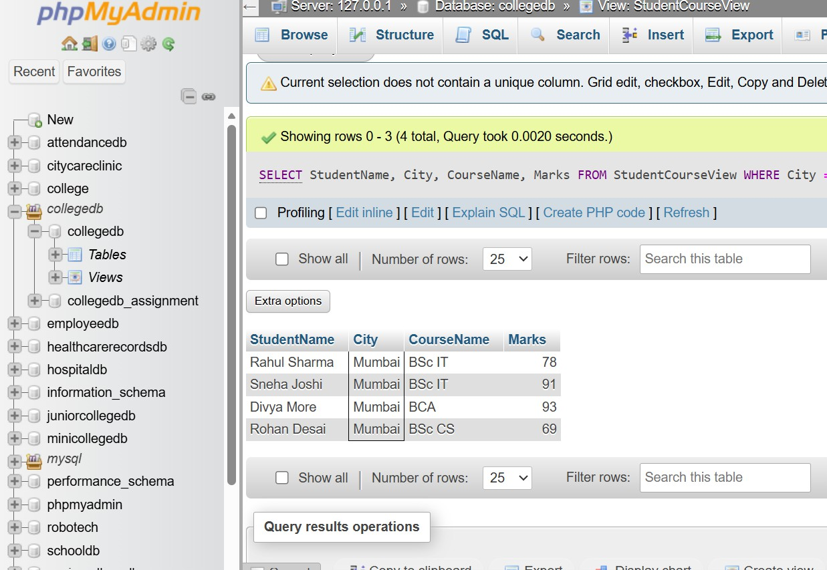

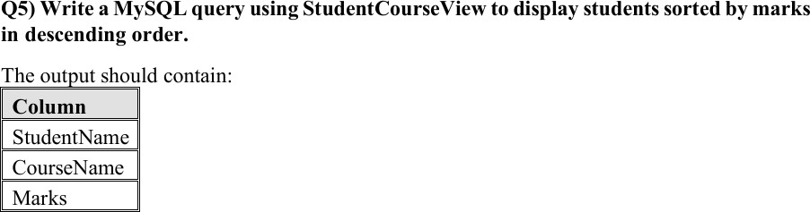

SELECT StudentName, CourseName, Marks FROM StudentCourseView
ORDER BY Marks DESC;

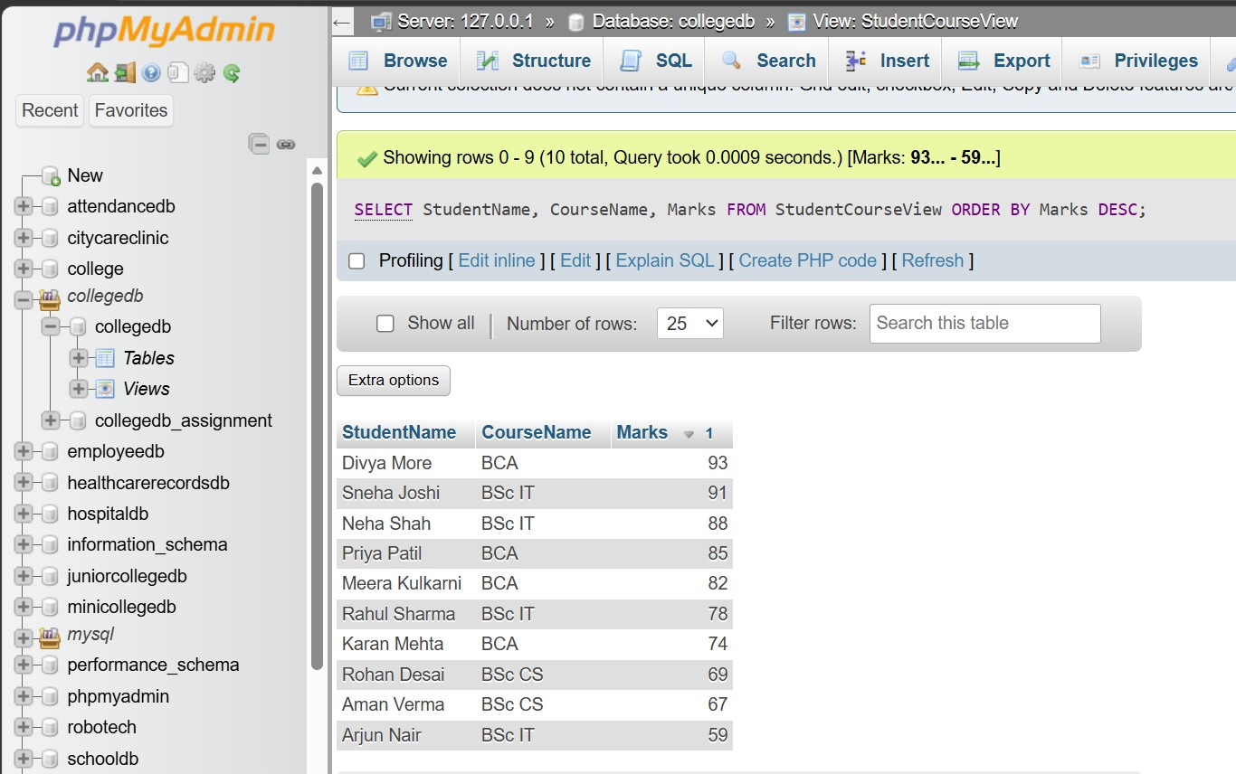

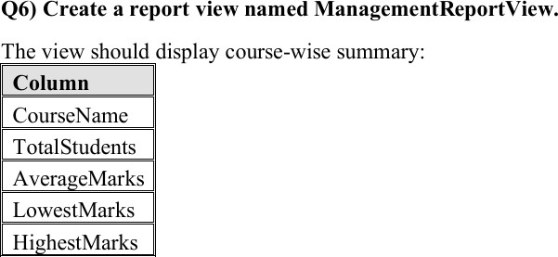

CREATE VIEW ManagementReportView AS SELECT
Course_View.CourseName, COUNT(Student_View.StudentID) AS TotalStudents, AVG(Student_View.Marks) AS AverageMarks, MIN(Student_View.Marks) AS LowestMarks, MAX(Student_View.Marks) AS HighestMarks
FROM Course_View

LEFT JOIN Student_View
ON Course_View.CourseID = Student_View.CourseID GROUP BY Course_View.CourseName;

-- Display Management Report
SELECT * FROM ManagementReportView;
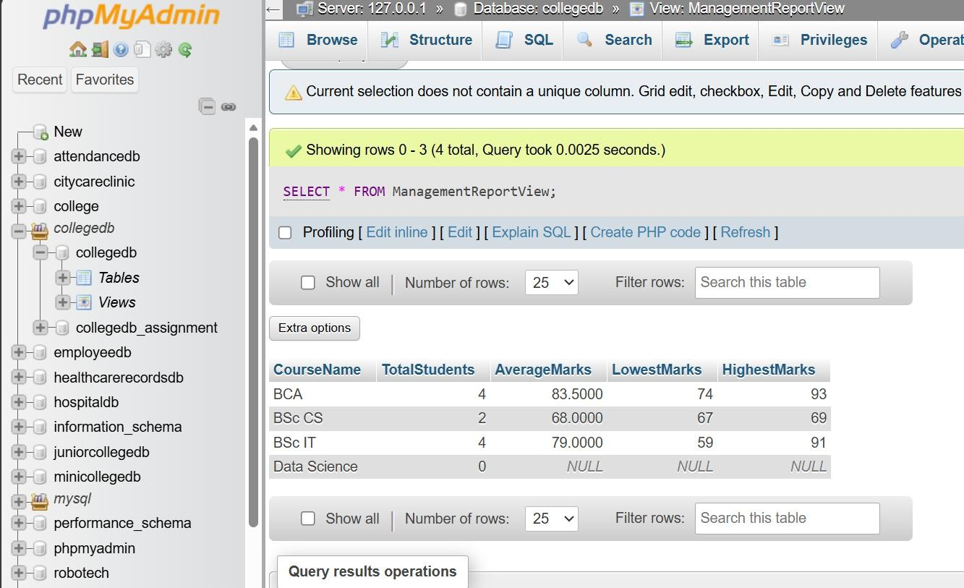

Explanation
ManagementReportView is useful for reporting because it provides a course-wise summary of student performance in a simple and organized format.

